Lunch on the Lake- Sept. 7
Something a little different
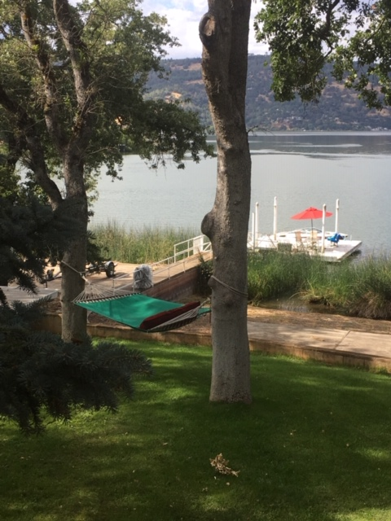
KBSC has been invited to hold our LOL @ David Dyssegard’s lake house in Whalen Cove. This will be a raft up with the committee boat along the dock (about 7ft. deep) and the other boats (motors and sails) tying up to the committee boat. The lake is about 9 ft. and more just a few feet from the dock. This will be a BBQ put on by KBSC -just BYOB and a swimsuit. The water looks very clean in the Cove.

The committee boat can hold 8 people. This would be good for people who don’t want to sail down to Whalen Cove (about ½ hr. away). If you think you’d like to go on the CB please let me know as soon as possible. It would be helpful if everyone RSVP’d and let us know what your plans are (valada519@gmail.com).
Boats to leave Braito’s Marina at noon on 9/7/19.
Map

